Topic:

Independently Researched Essay:

XXX

AI & Humanity - Ethics of Data Science

Prof. Dr. Sebastian Köhler

Master of Applied Data Science 2021

Semester 2.2

Dennis Simon Merlin Blaufuss

dennis_blaufuss@web.de

Walter-Hesselbach-Straße 54

60389 Frankfurt am Main

8458109

31st July 2022

Contents

1. Introduction 1

2. Main Part 2

X. Summary 3

Bibliography V

Statement of Certification VI

# 1. Introduction

# 2. Main Part

# 3. Summary

# Bibliography

**There are no sources in the current document.**

# Statement of Certification

I hereby confirm that this thesis constitutes my own work, produced without aid and support from persons and/or materials other than the ones listed. Quotation marks indicate direct language from another author. Appropriate

credit is given where I have used ideas, expressions or text from another public or non-public source.

The paper in this or similar form has never been submitted as an assessed piece of work in or outside of Germany. It also has not yet been published.

Frankfurt am Main, 31st July 2022 .

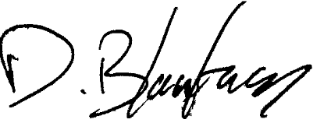

.

Dennis Blaufuss